Green Field Flow Modeling Workflow
John R. Fanchi
Department of Engineering and Energy Institute
Texas Christian University

Fort Worth, TX

j.r.fanchi@tcu.edu

June 12, 2010

Excerpted from Integrated Reservoir Asset Management, John R. Fanchi, Elsevier-Gulf Professional Publishing, Burlington, Massachusetts ,2010

Different workflows exist for designing, implementing and executing reservoir asset management projects. A typical workflow needs to identify project opportunities, generate and evaluate alternatives, select and design the desired alternative, implement the alternative, operate the alternative over the life of the project, including abandonment, and then evaluate the success of the project so lessons can be learned and applied to future projects. Reservoir flow models, which are also known as dynamic models, can play a significant role in comparing alternatives, selecting the optimum reservoir management plan, and assessing the success of the project as it is being implemented and operated. A modern flow modeling workflow for green fields is described below for an oil field. The workflow can be extended to reservoir assets ranging from gas fields to geothermal reservoirs. More details on green fields and workflows for brown fields are presented in Fanchi [Integrated Reservoir Asset Management, Elsevier-Gulf Professional Publishing, Burlington, Massachusetts, 2010].

Green Field Flow Modeling

Green fields include discovered, undeveloped fields, and fields that have been discovered and delineated but are undeveloped. Well test information may be available, but green fields have little or no production information to constrain the selection of reservoir realizations or calibrate uncertain model parameters. In this case, it is valuable to have a workflow that can quantify uncertainty. The workflow in Table 1 provides a probabilistic forecast that is useful for green fields.

Table 1
Green Field Flow Modeling Workflow
Step | Task
G1 | Gather Data
G2 | Identify Key Parameters and Associated Uncertainties
G3 | Generate Forecast of Field Performance Results
G4 | Generate Distribution of Field Performance Results

Risk analysis generates probabilities associated with changes in model input parameters. Allowed parameter changes must be constrained within ranges that are typically determined by the range of available data, information from analogous fields, and the experience of the asset management team. Parameters that may be used in the study include any model input information, such as reservoir characterization parameters, geologic realizations or static models, rock-fluid interaction parameters, well properties and well locations.
As an illustration, consider an example reservoir called the Valley Fill reservoir prior to the acquisition of historical production data. In this situation, the Valley Fill reservoir is a green field. To be specific, we identify three key parameters: porosity, permeability, and pressure at the water-oil contact (PWOC).
Every reservoir flow model run that uses a complete and unique set of model input parameters constitutes a trial. A set of trials is used to generate probability distributions. The number of trials depends on the number of parameters being considered and the desired level of analysis. Design of Experiments (DoEx) is a methodology for simultaneously and systematically varying a set of uncertain factors. The number of trials determined by experimental design depends on the number of factors and the number of values, or levels, used. A full factorial design uses all combinations of levels for all factors.
In our Valley Fill illustration, we design a set of trials that uses three parameters at three different levels (minimum, most likely, maximum). The number of trial runs is $3^{3}=27$ trial runs. The Valley Fill design is a 3-level full factorial design. Figure 1 shows allowed cases for a 2-level ($2^{3}=8$) and a 3-level ($3^{3}=27$) factorial design. The 2-level design uses minimum and maximum values, while the 3-level design uses minimum, maximum, and most likely values. The 3-level design covers more of the DoEx parameter space. The origin of the DoEx parameter space in Figure 1 is not used in the 2-level design, but it is used in the 3-level design where it denotes the case (Case 14) that uses the most likely value of all three parameters. Other DoEx techniques have been developed to approximate a full factorial design by using fewer trials. Approximation techniques are necessary when the number of parameters increases since number of cases in a full factorial design with m parameters with n levels is n^{m}.
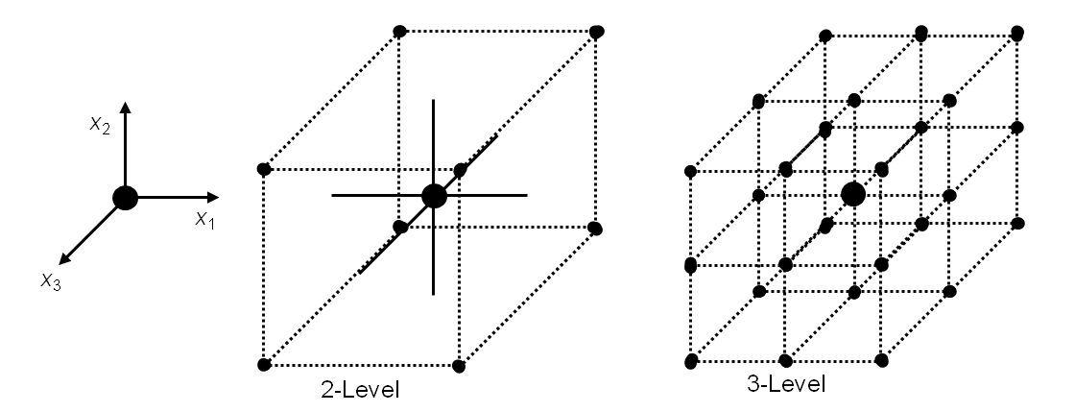

Figure 1. DoEx Parameter Space

All 27 trials were run using a reservoir flow model. Results for reservoir depletion are shown in Figures 2 for a period of 3 years. The models are comparable in the first few months, but begin to diverge as the forecast continues. Since we do not have historical data to decide which forecast is correct, we need to consider them all.

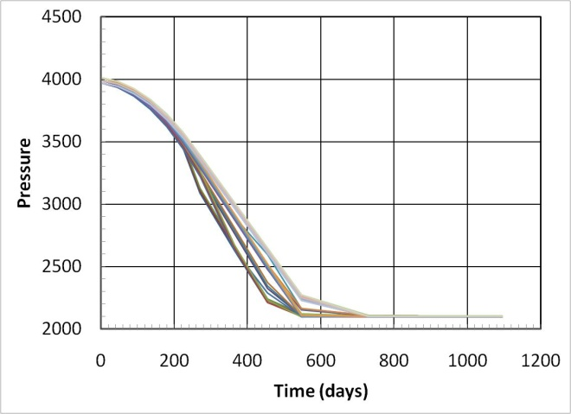

Figure 2A. Dynamic Model Results for a Green Field: Pressure (psia)

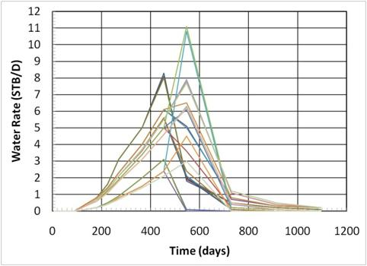

Figure 2B. Dynamic Model Results for a Green Field: Pressure (psia)

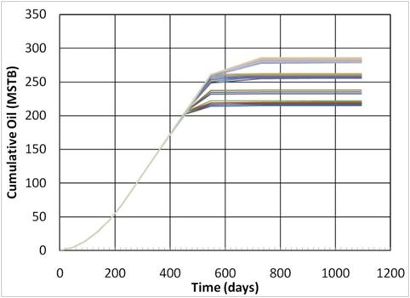

Figure 2C. Dynamic Model Results for a Green Field: Cumulative Oil (MSTB)

If we assume the results of each model are normally distributed, we estimate the average cumulative oil recovery at the end of three years as 255 MSTB with a standard deviation of 25 MSTB. Figure 3 shows the probability distribution for cumulative oil recovery for the green field.

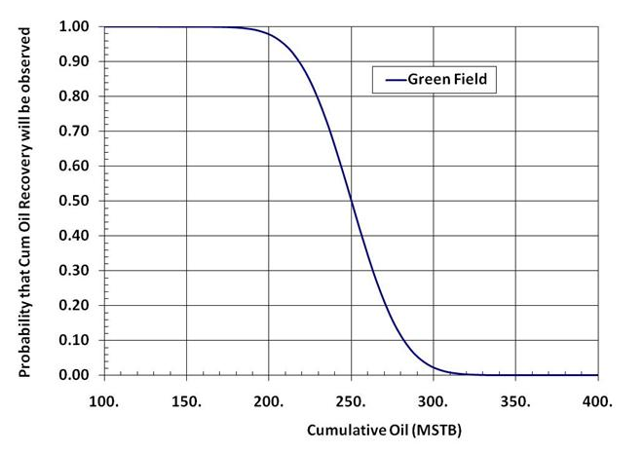

Figure 3. Green Field Cumulative Oil Recovery

The results in Step G3 can be used to identify key parameters. We can rank key parameters by developing a regression model of the reservoir flow model results. The regression model is called a proxy. Equation (1) is a linear regression model for our Valley Fill example
(1)
where the regression parameters represent porosity, permeability, and pressure at the water-oil contact (PWOC), respectively, and the regression variable is cumulative oil recovery. The coefficients are determined by regression analysis. Equation (1) is a model of a linear response surface. The response surface represents the relationship between input variables and output response. A non-linear response surface includes products of regression parameters, such as the following quadratic response surface
(2)

with additional regression coefficients . Figure 4 compares the linear regression model and a squared regression model without parameter interaction, that is, a quadratic regression model with for the Valley Fill example. In this example, cumulative oil recovery is most affected by porosity, and least affected by PWOC. Consequently, porosity is the heavy hitter.
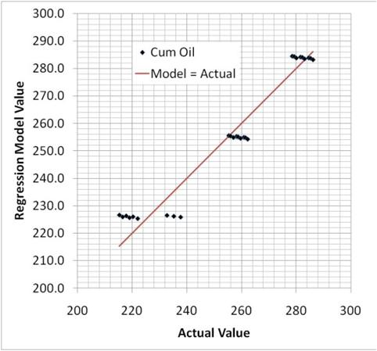

Figure 4A. Proxy Model Results for Green Field Cumulative Oil Recovery: Linear

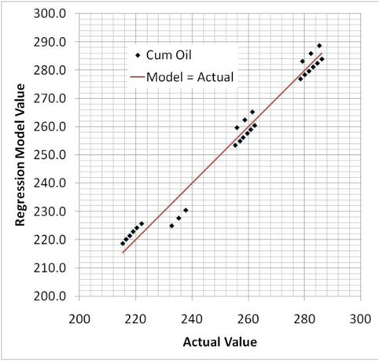

Figure 4B. Proxy Model Results for Green Field Cumulative Oil Recovery: Squared

The proxy models can be used to perform Monte Carlo analysis. The advantage of Monte Carlo analysis is that hundreds or thousands of proxy cases can be run to generate a probability distribution of results. The quality of the Monte Carlo analysis depends on the quality of the proxy and the distribution of regression parameters. Given the distributions and a proxy, a large number of trials can be run in a few minutes. The set of Monte Carlo runs can then be analyzed to determine the relative importance of regression parameters and the probability distribution associated with the regression variable.
The sophistication of the green field analysis workflow can imply a level of certainty that is deceiving. It is important to remember that reservoir flow model results depend on an assessment of uncertainties that are quantified based on limited sampling of data, selection of parameters and associated uncertainty ranges that may be incomplete or inadequate, calibrated to little or no field performance, and use of parameter distributions that may only be approximate. Despite these limitations, the workflow for analyzing a green field is repeatable, can quantify uncertainty, and facilitates an objective appraisal of competing project options.

